<The Most Popular Cat on the Internet!> (ReplaceMe: need official logo art)

Design Document

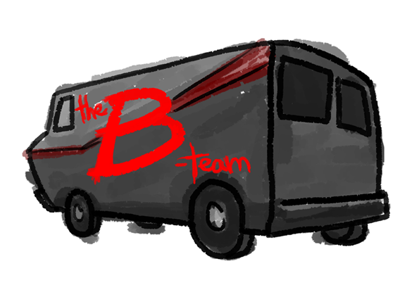

Programming and Story

Thomas Dye [thomas@tfenet.com](mailto:thomas@tfenet.com)

Cary Kawamoto [cary.kawamoto@gmail.com](mailto:cary.kawamoto@gmail.com)

Andrew VanKooten [andrewvankooten@gmail.com](mailto:andrewvankooten@gmail.com)

Holden Woelfl [hjwoelfl@gmail.com](mailto:hjwoelfl@gmail.com)

Art

Lori Collins [loriofpandora@gmail.com](mailto:loriofpandora@gmail.com)

Concept and Story

Amani Dye [amaniahmeddye@live.com](mailto:amaniahmeddye@live.com)

Music

Unlisted.

Contents

2 Version History 3

2.1 April 27, 2016 3

2.2 May 2, 2015 4

3 Game Overview 5

4 Game Elements 5

4.1 Concept 5

4.2 Game Tags 5

4.3 Genre 5

4.4 Game Location 5

4.5 Characters 5

4.5.1 Player 5

4.5.2 Other Cats/Non-Player Cats 6

4.5.3 Cat Posse 6

4.5.4 Humans 6

4.5.5 Celebrity Cats 6

4.6 Gameplay 6

4.6.1 Performing Cat Tricks 6

4.6.2 Cat tricks 6

4.6.3 Amusement Level 6

4.6.4 Star Power 6

4.7 Completion Standards 7

4.8 Game Length 7

5 Character and World Art 7

5.1 Player 7

5.1.1 Concept Basic (undetailed) Body Poses 8

5.1.2 Concept Sample Body Variations and Colorings 9

5.2 Other Cats 9

5.3 Celebrity Cats 9

5.4 Humans 9

5.4.1 Concept Basic (undetailed) Body Poses 10

5.4.2 Concept Sample Body Variations 10

5.5 Hazards 10

5.6 Dimensionality 11

5.7 Background Textures 11

6 Audience, Platform, and Market 11

6.1 Target Audience 11

6.2 Platform 11

6.3 Similar Games 11

6.4 Uniqueness and Appeal 12

7 Core Game Mechanics 12

7.1 Movement 12

7.2 Adding Cats to your Posse 12

7.3 Retaining Cats in your Posse 12

7.4 Getting Noticed by Humans 13

7.5 Getting Humans to Film You 13

8 Other Game Mechanics 13

8.1 Special Encounters 13

8.2 Distractions 13

8.3 Hazards 13

8.4 User Interface 14

8.5 Visual Feedback 14

8.6 Music and Sound Effects 14

9 Rejected Ideas 14

# Version History

## April 27, 2016

Initial draft of the document.

Added:

* Game Overview
* Dame Details
* Audience, Platform, and Marketing
* Game Mechanics
* Characters and Art
* User Interface
* Music and Sound Effects

## May 2, 2015

Changed underlying concept of game and genre from a cat themed zombie horde game.

* Moved “Mutant Werecats from Outer Space” specific content to Rejected Ideas section.
* Started “The Most Popular Cat on the Internet!” content.
* All sections updated or rewritten (not itemized) to match new game concept, story, and vision.
* Characters, concept art, and gameplay prototypes remain the same.

# Game Overview

“The Most Popular Cat on the Internet!” is a casual 2D side-scrolling pattern matching game where you, Piper the cat, gather other cats to help you to win the adoration of your human admirers, to become the most popular cat on YouTube.

# Game Elements

## Concept

Piper the cat lives in a small house owned by an old woman along with his many brothers, sisters, and cousins.

Piper has a cushy life with his owner, but he’s ambitious, and decides to strike it out on his own by becoming the most popular cat on YouTube. In order to attain this goal, Piper knows that he has to attract the attention of humans and get them to film him doing cat tricks. However, it turns out that being an Internet cat celebrity is a lot harder than it appears.

Piper is able to attract the attention of humans, but the more popular he becomes, the more he has to compete with other Internet cat celebrities (such as Grumpy Cat and Bubz). He decides his way to Internet fame is through his natural leadership abilities and his extreme cuteness, and seeks out other cats to join him in his quest for stardom.

## Game Tags

Action, Combos, Cute, Single Player, 2.5D, Friend Gathering, Non-Violent

## Genre

“Pattern and Movement Matching Game”

This is a casual game. It shouldn’t require a lot of strategy or micromanagement. Only simple actions. The player is one step ahead of the current situation, and has only basic reactions.

## Game Location

Gameplay will occur in select indoor rooms and outdoor areas such as neighborhoods.

## Characters

### Player

The player, Piper, is a wannabe Internet celebrity cat. This cat is differentiable from the other cats in the game by a unique texture and coloring. The player has the ability to walk, run, jump, and perform cat tricks to attract the attention of human admirers.

### Other Cats/Non-Player Cats

If watching one cat do cute tricks is fun, watching many other cats all do them at the same time is even better. Non-player cats can be found throughout levels and will join your posse if they are impressed by the quality of your cat tricks.

### Cat Posse

The cat posse is a group of other cats that follow the player as he or she moves around a level. Your posse will perform tricks in unison with the player. A larger posse allows the player to more easily obtain the attention of humans and amuse them.

### Humans

Humans are non-playable characters who will film Piper and his posse of other cats. The player must get the attention of humans. If humans find you interesting, they will record you on their phones’ cameras. Humans also react to the quality of entertainment, illustrated by an amusement level UI element.

### Celebrity Cats

Celebrity cats may join your posse if encountered in a level and they are won over by the quality of your cat tricks. A celebrity cat can significantly increase your appeal to humans. Adding a celebrity cat to your posse is more difficult than a regular non-player cat.

## Gameplay

### Performing Cat Tricks

Cute cat tricks can be used to get the attention of an audience in the form of other cats and humans. Performing tricks correctly will increase audience amusement level and interest in the player, and failures will decrease it.

### Cat tricks

Cat tricks are executed by the player seeing a combination of controller buttons to press, and then repeating that combination on a controller. The player must repeat the pattern within a short time span, in the correct order, and without incorrect inputs. If the player is successful, the player’s cat (and cat posse, if available) will perform a trick.

### Amusement Level

Amusement level is the measure by which the player is graded. Amusement level is raised by performing cat tricks for humans. Amusement level will rise faster and scales with the size of the cat posse. Amusement level will deteriorate over time if no cat tricks are being performed.

### Star Power

Several cat tricks performed in a row unlocks star power, a bonus that allows audience amusement levels to increase more rapidly. A streak of successful cat tricks causes the patterns to be longer and more complicated.

## Completion Standards

The player must get a level-specific number of humans to film Piper while maintaining the minimum Amusement Level for a small time period. These two goals must be completed in a prescribed total time allowed for each level.

When the required number of humans are filming you and the minimum amusement level is attained, the player must sustain the amusement level for 10 seconds so the humans can record quality footage and upload their videos to the Internet.

## Game Length

There are multiple levels that are created for this game, with each level taking a different amount of time to complete based on its difficulty, but as this game is designed for casual and completionist players, the time to play the game is variable. Levels are intended to be replayed to complete secondary challenges and earn better scores.

# Character and World Art

## Player

The player cat should be visually distinct from any other cat. Movement will be restricted two speeds (walking or running) and allow jumping. Visually, the character is restricted to facing left or right. As the focus of this game, cats have the most distinct poses and the most movements. At minimum, art assets for the following states need to exist:

* Sitting (Can be static images, more variety is better. Entering this state will load one at random.)
  + Looking forward
  + Looking toward screen
  + Looking away from screen
* Standing (Ready to walk, maximum tail motion.)
  + Looking forward
* Walking forward (minimal tail movement, looping different leg positions)
* Jumping (Can be static poses)
  + Leap (traveling upward)
  + Mid-air (top of arc)
  + Landing (traveling downward)
* Trick 1: Lying on back (inviting belly rub, rolling side to side)
* Trick 2: Stand on hind legs (minimal back and forth movement)
* Trick 3: Sit and bat at imaginary object (with batting leg movement)

All sitting, standing, and walking sprite sheets should be of a common (left, right) direction which can be mirrored. Walking up or down on the screen will cause the player to “shimmy” with left or right walking motions. Running will be accomplished by running the sprite sheet at a faster frame rate.

### Concept Basic (undetailed) Body Poses

Sitting

Walking

Jumping

### Concept Sample Body Variations and Colorings

Sitting

## Other Cats

Other cats should be visually distinct from the player cat, differentiated through different fur markings. Other cats require the same range of motion as the player cat.

## Celebrity Cats

Celebrity cats require do not require the same range of motion as the player cat. These cats will be limited to the following basic motions and poses:

* Sitting
  + Looking toward screen
* Standing (Ready to walk, minimum tail motion.)
  + Looking forward
* Walking forward (with looping different leg positions)

## Humans

Humans have the most visual variety with character design but are restricted to walking, standing, and taking videos. Visually, the character is restricted to facing left or right. At minimum, art assets for the following states need to exist:

* Standing
  + Normal (loitering)
    - Neutral facial expression
    - Happy facial expression
  + Taking videos (happy facial expression, posed with smart phone or point and shoot camera)
* Walking forward (with minimal arm movement and looping different leg positions)

### Concept Basic (undetailed) Body Poses

Standing

### Concept Sample Body Variations

Standing

## Hazards

Currently there are no assets for hazards.

## Dimensionality

This 2.5D game uses the following axis alignments to define perspective:

* Facing right: 0 degrees
* Facing left: 180 degrees
* Facing up: 60 degrees
* Facing down: 240 degrees

## Background Textures

Backgrounds will be made to be modular, so they can be easily be reused to enable larger levels. These backgrounds will include both inside and outside elements. Exterior environments must conform to the perspective angles described in Dimensionality. All backgrounds will contain three elements:

* Sidewalk / Floor: Space where the player and humans can walk. This is going to be the bottom half of the background.
* Building / Wall: The top half of the background where the player and humans cannot walk on.
* Obstacles: Random elements, such as trees, on the sidewalk / floor part of the background which the players cannot walk over. Characters will appear to pass in front of them or behind these objects depending on their relative positions within the scene.

# Audience, Platform, and Market

## Target Audience

This game appeals to players who are looking to pick it up and play for a few minutes, as well as completionist type players who will be able to go back to previously completed levels, and try to meet specific challenge objectives that will give them bonus throughout the game.

## Platform

This game is being developed with the intention of running on desktop platforms using either keyboard or gamepad controls.

## Similar Games

There are a few games currently on the market that present similar themes:

* **Space Channel 5**

Space Channel 5 is a rhythm-based video game. Challenges are handled by the player repeating a sequence of actions to the rhythm of the music. Successful execution of these sequences allows the player to progress through the game. While our game does not contain a rhythm element, matching patterns of controller inputs is a key feature of our gameplay.

<https://en.wikipedia.org/wiki/Space_Channel_5>

* **River City Ransom**

River City Ransom is an example of the “2.5D” environment that will be utilized in this game, and the world design will reflect this. Movement in this game will also be similar to how movement will be handled in this game. The player will be facing either left or right and the player will travel up and down facing these directions also.

<https://en.wikipedia.org/wiki/River_City_Ransom>

* **Agar.io**

Agar.io is a multiplayer game where players start as a circle and compete with other players to “eat” smaller circles to grow in size. This is similar to Piper’s area of influence and his ability to have cats and humans follow him. As he brings other cats into his horde, his area of influence increases and allows him to get the attention of humans and cats further and further away.

<http://agar.io/>

## Uniqueness and Appeal

Description text.

# Core Game Mechanics

## Movement

The player has influence over Piper's posse, directing travel locations by moving around a map. If a human is encountered, the player must move the posse toward the human. As the posse also becomes aware of the human (through relative proximity), the posse will independently move to get the human’s attention.

## Adding Cats to your Posse

When Piper approaches a new cat in the wild (a challenger), Piper initiates an encounter by “staring down” the challenger. The challenger responds by performing a sequence of cute cat actions, such as exposing his belly, purring, loafing, etc. Piper shows performing skills by replicating the sequence without error. The challenger cat is so impressed, he joins Piper's posse. Additional cats joining your posse increases your effectiveness of appealing to humans.

## Retaining Cats in your Posse

Other cats will lose interest in Piper over time if he is not actively trying to fulfill his ambition to become the most popular cat on the Internet. Unsuccessfully executed tricks and lengthy time spent walking around will cause them to grow bored and bolt away.

## Getting Noticed by Humans

Humans are very aware of cats doing unexpected things or getting close to them. Humans will stop walking when Piper or another member of his posse get their attention. If cute cat tricks are successfully performed, the human will continue to pay attention and their amusement level will rise. No action or unsuccessful tricks will cause them to grow bored with you, and they will continue on their way.

## Getting Humans to Film You

A human will film Piper when they are actively being amused by cute cat tricks after a certain amusement level threshold has been met. Piper and his cat posse must continue to build up amusement level in humans through successful completion of cat tricks to encourage humans to continue to record the cat antics.

If the player does not successfully perform cat tricks, the human will begin to lose interest and put their camera away.

# Other Game Mechanics

## Special Encounters

Sometimes celebrity cats appear on the scene while you’re trying to attract the attention of a human. When this occurs, attention is taken away from you and directed toward the existing celebrity cat. To counter this, you must “defeat” the celebrity cat by outperforming them. This will re-attract the attention to you and your posse. Additionally, the Internet celebrity cat will concede defeat and join your posse.

## Distractions

Distractions are things that will cause cats in your posse (cats are easily distracted) to leave. It is the player’s job to see these distractions and maneuver their group of cats around them; keeping the distraction out of Piper's area of influence, which gets larger when more cats are added. Some examples follow.

* Boxes: Cats enjoy sitting in boxes, and if they find one it will jump in.
* Balls of Yarn: Cats love playing with these and if one is encountered, a cat will leave to play with it.
* Rocking Chairs: These are fun for cats to sit on, so if encountered a cat will leave your posse to sit on it.

## Hazards

Hazards will be encountered in more difficult levels. The player will have to avoid these by keeping them out of Piper's area of influence, which is more difficult when there are more cats in the horde. These hazards cause both a few humans and cats to leave, causing the player to try and find more if they are encountered. Some examples follow.

* Cucumbers: Some humans will place cucumbers behind cats in order to surprise them, and other humans find this hilarious making them pay more attention to that. The cats scared by the cucumber will run off and some humans will follow.
* Dogs: Dogs may be roaming the world and if the posse encounters them, the dog will begin chasing a cat. Humans, not wanting to see a cat and dog fight, will leave.
* Lost Cat Posters: Owners of the cats in your posse may miss their cat, so they will put up missing cat posters. If a human sees the poster of one of the cats in your posse they will pick up that cat and take it to the owner for a reward.

## User Interface

Description text.

* Number of people recording you
* Amusement level

## Visual Feedback

Successfully completing controller combinations for executing cat tricks causes Piper or other cats in his posse to begin a trick animation or pose. There is no direct controller mapping for initiating cat tricks. Bonuses such as Star Power provide additional visual effects to reward the player.

## Music and Sound Effects

No music and sound effects are currently made. Sound effects are expected to be created or located by us, and music will be provided by Danny Morris: https://soundcloud.com/dannymorris-1

# Rejected Ideas

**Game Overview**

Mutant Werecats from Outer Space is a casual 2D side-scrolling “horde management” action game where you control a growing swarm of housecats, helping aliens take over the Earth by converting humans into felines.

**Concept**

A shadowy alien race enlists the help of the dominant species on earth (as known by them through research conducted on YouTube): the housecat. They decide to turn ordinary housecats into “werecats” that look like normal cats, but have the ability to turn unsuspecting humans into cats by a process known as “bapping.” The converted humans join the werecats as members of their horde to grow the horde in size and over power larger groups of humans until there are no more humans are left.

One morning you wake up and realize you’re a cat filled with glorious purpose and bent on world domination. It is your goal to build a horde of cats so you can take over larger and larger areas of the world until ultimately everyone is converted to a cat. The player wins if influence is maintained over the horde until all humans are converted, but long periods of time without adding humans to your horde or obstacles in the world will cause your horde size to decrease, preventing you from winning.

**Game Tags**

Mob Management

**Genre**

“Casual Horde Management”

**Player**

The player starts the game as a single cat that has been turned into a werecat by the aliens. This cat is differentiable from the other cats in the game by a unique texture, but there is some variation with this texture to allow for some player choice.

**Target Audience**

Mutant Werecats from Outer Space is a casual, action game meant for all ages.

**Platform**

This game was created with Windows PC and mobile in mind. The UI is designed to be simple and easy to use making both the platforms ideal choices. There is also a possibility that this game can be adapted to be used with a console.

**Similar Games**

* **Zombie Horde Game**

This game has the player control a zombie to find humans and stay by them to convert them to zombies that will join your horde. This game is similar to ours with respect to the convert humans and horde mechanic. Mutant Werecats from Outer Space introduces additional mechanics and levels, while featuring lighthearted elements and humor making this game more appropriate to broader audiences.

<http://www.freewebarcade.com/game/zombie-horde-game/>

* **Agar.io**

Agar.io is a multiplayer game where players start as a circle and compete with other players to “eat” smaller circles to grow in size. This follows Mutant Werecats from Outer Space’s theme of growing the size of your horde, but with the additional challenge of finding humans to convert and with no multiplayer component.

<http://agar.io/>

* **The Last Guy**

Released as a digital download for the PS3, this game is somewhat similar to Snake; as survivors are rescued, they are added to the chain of people following the Hero. A longer chain makes it easier to surround and add new survivors, but also means more places to contact enemies on the field.

<https://www.playstation.com/en-us/games/the-last-guy-ps3/>

* **Katamari Damacy**

The player controls The Prince, tasked by his father The King of All Cosmos to roll up and collect mundane objects from Earth to restore the stars in the sky. Each stage has different requirements for completion, including size, quantity, and item types. The level and hazards scale up as the player grows in size -- some areas become accessible, and the nature of certain challenges changes.

<https://en.wikipedia.org/wiki/Katamari_Damacy>

**Conversion**

The player converts humans into cats by “bapping” them on their head. Being “bapped” and converted to a cat is permanent. Humans must be in a prone position to be “bapped” on the head by a cat, which is easier when the horde is small and gets harder when the horde grows. The player must stay by the converting human for a set amount of time, depending on the difficulty, in order to ensure that it becomes part of the players horde, otherwise the new cat will run away.

**Influence**

The alien’s influence over the player, and by extension, the player’s influence of other cats, is temporary. A countdown shows the amount of time you have influence over your cat. If another human is converted to a cat, your influence timer stops and a new timer starts on the newest member of your horde. Each additional cat added to your horde gets a new influence timer with the previous timer stopping. Allowing the timer to expire means the player loses influence over that particular cat, and it walks away (as a normal cat). If the player loses the horde and player’s timer resumes and expires, the player becomes a normal cat and the game is lost.

**Small Horde**

The player will not be able to overwhelm humans with a small horde, so techniques must be used to allow werecats to bap humans, who are physically larger than cats. Techniques may include walking up to humans and rubbing their legs, purring, rolling around on the ground--anything to get the human to bend over and pet the cat. Once prone, the werecat may bap the human.

**Large Horde**

Humans are less trustworthy of the larger group of cats and may employ countermeasures (see environmental and active hazards section) to avoid conversion and try to break up the horde. The horde must corner humans before the human can be overwhelmed and bapped.

**Environmental Hazards**

Humans will randomly place environmental hazards in the way of the horde to try to disperse it, because large groups of cats are suspicious. These appear on easier difficulties when the horde is not incredibly large.

* Boxes
* Cucumbers
* Rocking Chairs
* YouTubers trying to film cats
* People trying to pick up and leaving with cats

**Active Hazards**

After the horde has reach a large enough size and the difficulty is high enough, humans will begin to throw these at the horde to make it disperse. The player must deal with these with directly, with overwhelming force, before too many cats are lost.

* Dogs
* Animal Control
* Balls of Yarn

**Difficulties**

There are four difficulties in the game. Each level has a set difficulty and after the player beats a level at the set difficulty, they can go back and play it at any difficulty. The difficulty help determine the values and modifiers of some game play elements.

* **Easy**: Few humans are spawned and the horde size needed to beat the level is low. The time needed to convert a human is low, and the overall timer for you and other cats is higher. Humans are also less alert to the threat of the horde.
* **Average**: More humans are spawned, and the required horde size is larger. The conversion timer is higher, and the overall timer is lower. Humans are slightly more alert, and begin placing environmental hazards.
* **Hard**: Even more humans are spawned, and required horde size is even larger. The conversion timer is much higher, and the overall timer is much less. Humans are way more alert and are placing active hazards to stop the horde.
* **Challenge**: The largest amount of humans are placed, and horde size needed is close to 100 percent. The conversion timer is at the highest, and the overall timer is much smaller. The active hazards are even more dangerous.

**Basic (undetailed) Body Poses**

Kneeling (and being bapped)

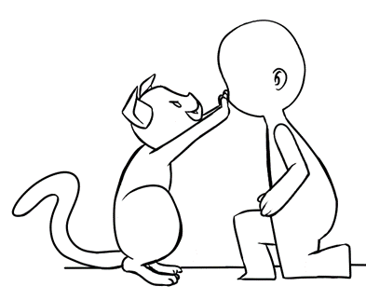

**User Interface**

The UI in this game is going to reflect the simple and casual nature of the game. Immediate information will be reflected on the screen such as the number of zombies in the horde, and the percentage of humans left in the level. Other information the player needs will be reflected in the objects on the screen, such as the influence on a cat will be represented by the color of the eyes of that cat.

The game is designed with both computer and mobile inputs in mind, so the controls are designed to be simple and intuitive. The player cat will be controlled by using the mouse and “bapping” a human by clicking.

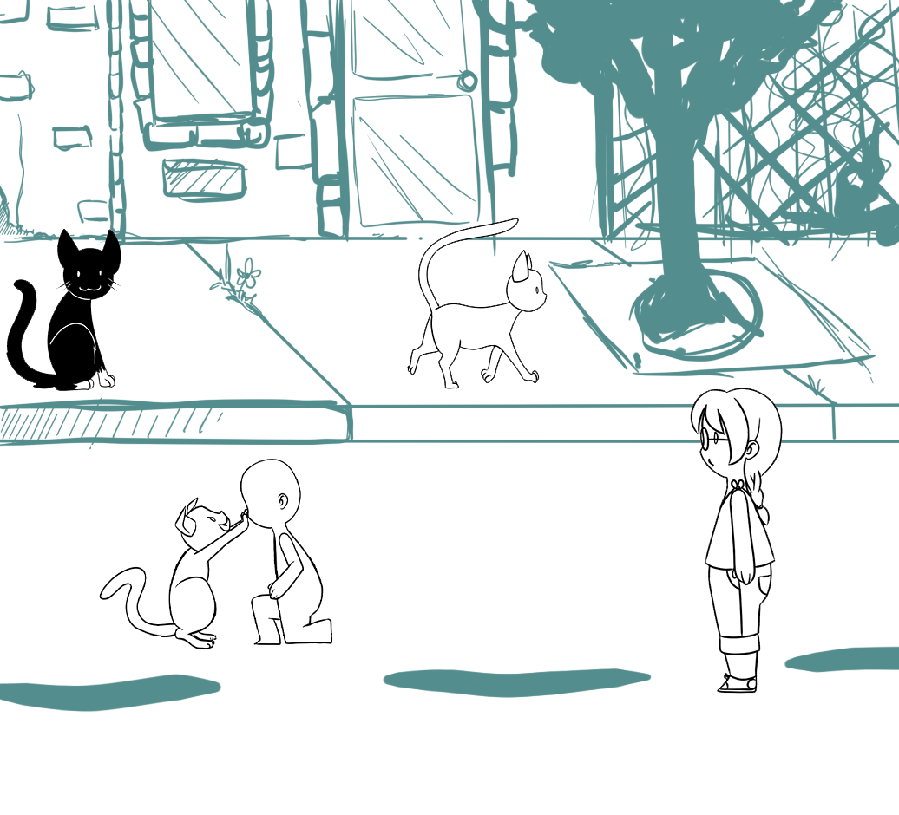

The above image is a composite mockup of potential gameplay. UI elements are not currently reflected in this image.